QUADRILATERALS

A quadrilateral is any closed shape with 4 sides. All the following shapes are quadrilaterals.

Trapezoid
- A trapezoid has exactly one pair of opposite sides parallel.
- An isosceles trapezoid has one pair of parallel sides and the other pair is congruent (same length).
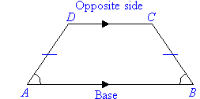

Parallelogram
- Opposite sides of a parallelogram are parallel and congruent (same length).
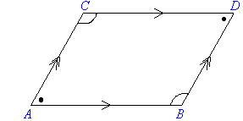

Rhombus
- All sides of a rhombus are congruent (same length).
- Opposite sides are also parallel.
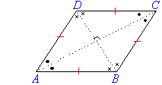

Rectangle
- Opposite sides of a rectangle are parallel and congruent (same length).
- All angles are right angles (equal to 90°).

Square
- Opposite sides of a square are parallel and all sides are congruent (same length).
- All angles are right angles (equal to 90°).
